DEM_Ref
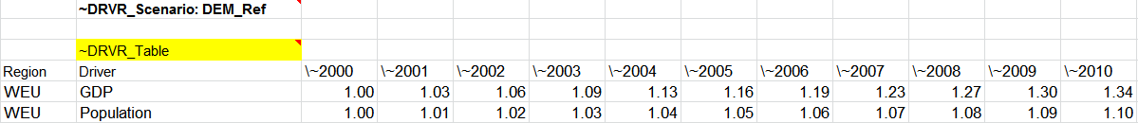
DEM_Test
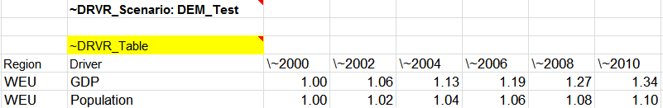
VFE_Browse
